Nur Falah
Muslim Companion
Google Play Console Submission
Prepared: August 2026
Falah Consultancy Ltd

Table of Contents
1. Store Listing Basics
2. Full Description
3. Short Description
4. What's New
5. Graphic Assets
6. Category & Tags
7. Content Rating
8. Pricing & Distribution
9. Privacy Policy
10. Localization
11. App Store Optimization (Google Play)

1. Store Listing Basics
App Name | Nur Falah — Muslim Companion
App Name (max 50 chars) | Nur Falah: Muslim Companion (29 chars)
Short Description (80 chars) | Prayer times, Quran, Qibla & dhikr — your free daily Islamic companion
Primary Category | Lifestyle
Secondary Category | Education
Tags (max 5) | Islam, Muslim, Quran, Prayer, Religious
Free or Paid | Free
Contains Ads | No
In-app Products | None
Developer Name | Falah Consultancy Ltd
Developer Email | wanjauhari@gmail.com
Developer Website | https://moslem.falahos.my
Privacy Policy URL | https://moslem.falahos.my/privacy

2. Full Description (max 4,000 characters)
Character count: 2,464

Nur Falah is your complete Muslim companion — a beautiful, free, and private app that brings everything you need for your daily Islamic practice into one place. No ads. No tracking. No account required.
🕌 Prayer Times
Get accurate prayer times based on your location with automatic detection. View the full daily schedule including Fajr, Sunrise, Dhuhr, Asr, Maghrib, and Isha — with the next prayer always highlighted so you never miss a salah. Choose from five trusted calculation methods: Muslim World League, ISNA (North America), Umm al-Qura, Egyptian General Authority, and Karachi University. Enable optional push notifications for prayer reminders.
🧭 Qibla Finder
Find the exact direction of the Kaaba from anywhere in the world. The built-in compass calibrates to your device sensors and shows bearing toward Al-Masjid Al-Haram (21.42° N, 39.83° E). Works offline after initial load.
📖 Holy Quran
Read the complete Holy Quran with all 114 surahs. Each surah includes Arabic text, English transliteration, and ayah count. Clean, distraction-free reading — just you and the words of Allah.
📅 Hijri Calendar
Stay connected to the Islamic calendar. View the complete Hijri date (day, Arabic month name, AH year) alongside the Gregorian equivalent. See weekday in Arabic, month number, and total days.
📿 Tasbih Counter
Digital dhikr counter with targets of 33, 99, 100, or 500 — the classic counts for Subhanallah, Alhamdulillah, and Allahu Akbar. Tap the counter or press space. Track your daily total.
💚 99 Names of Allah
Study the 99 Beautiful Names of Allah (Asma-ul-Husna) with Arabic calligraphy and English transliteration. Search any name instantly.
✨ Why Nur Falah?
- 100% Free — no subscriptions, no in-app purchases
- Works offline for Qibla and Tasbih
- Progressive Web App — installs to home screen
- Lightweight (< 1 MB) and fast
- Privacy-first: we collect no personal data
- Modern, beautiful design
- No ads. No tracking. No accounts.
Download Nur Falah today and make every moment of your day count.

3. Short Description (max 80 characters)
Prayer times, Quran, Qibla & dhikr — your free daily Islamic companion
Character count: 74/80

4. What's New
- Initial release
- Prayer Times with 5 calculation methods and notifications
- Qibla Finder with live compass
- Complete Holy Quran — all 114 surahs
- Hijri Calendar with Gregorian conversion
- Tasbih Counter with 33/99/100/500 targets
- 99 Names of Allah with search

5. Graphic Assets
Required:
Feature Graphic | 1024 × 500 px PNG/JPG
Screenshot 1 | Prayer Times — next prayer schedule with calculation method
Screenshot 2 | Qibla Finder — compass with Kaaba bearing
Screenshot 3 | Holy Quran — complete surah list
Screenshot 4 | 99 Names of Allah — grid with search
Screenshot 5 | Tasbih Counter — digital dhikr at target 33
Screenshot 6 | Hijri Calendar — Islamic date and Gregorian
Optional:
Promo Video | YouTube URL (30s-2min)
Phone Screenshots (tablets) | 7" & 10" tablet screenshots recommended
App Icon | 512 × 512 px — same as PWA icon
Daydream Screenshots | Not applicable (no VR)

6. Category & Tags
Primary Category | Lifestyle
Secondary Category | Education
Tags | Islam, Muslim, Quran, Prayer, Religious
Content Rating | Everyone (4+)
Installed Category | Default

7. Content Rating (Google Play Questionnaire)
Email: wanjauhari@gmail.com
IARC Questionnaire Answers
Sexual Content | None
Violence | None
Drugs/Alcohol/Tobacco | None
Hate Speech | None
User-generated content | No
Sharing location with strangers | No
Unrestricted web access | No
Digital gambling | No
In-app purchases | None
Predicted Rating | Everyone (4+)
Notes
The app contains no user-generated content, no social features, no in-app purchases, no advertising, and no external links to social media. It is a standalone utility app for Islamic practice.

8. Pricing & Distribution
Pricing | Free
Countries | All countries (worldwide)
Android Devices | Phones & Tablets (all form factors)
Pre-registration | No
Ads | None
Monetization | None — completely free
Note: The app is a Progressive Web App (PWA) wrapped via Trusted Web Activity (TWA) or linked from the Play Store as an installable PWA. No native code required.

9. Privacy Policy
Published at: https://moslem.falahos.my/privacy

Summary
- No personal data collected, stored, or transmitted
- Location data used on-device only for prayer times & Qibla — never sent to any server
- No analytics, tracking, or advertising SDKs
- No cookies or persistent identifiers
- No account or registration required
- All data stored locally in the browser
- GDPR and CCPA compliant by design
Full policy
The complete privacy policy is available at https://moslem.falahos.my/privacy and is included in the Privacy Policy section of both the Google Play Console and this document.

10. Localization
Language | Status | Priority
Arabic | Not yet localized | High — Quran Arabic already present but UI strings need translation
Malay (Malaysia) | Not yet localized | High — primary SEA market
Indonesian | Not yet localized | High — largest Muslim population globally
Urdu | Not yet localized | Medium — Pakistan & India
Turkish | Not yet localized | Medium — growing digital Muslim market
French | Not yet localized | Medium — large European Muslim population
German | Not yet localized | Low
Tip: Google Play favors localized listings in search. Prioritize Arabic, Malay, and Indonesian for the best organic discoverability.

11. App Store Optimization (Google Play)
Title Optimization
- Use: "Nur Falah: Muslim Companion - Prayer Times Quran Qibla"
- Include keywords naturally in the title for Google's algorithm
- Keep under 50 characters
Description Strategy
- Lead with "Prayer Times" — the most searched Islamic app keyword
- Mention "free", "offline", "no ads" — high-conversion trust signals
- Use emoji in descriptions (Google Play allows this and it improves CTR)
- Repeat key terms naturally: prayer times, qibla direction, quran reading, islamic calendar
Screenshot Optimization
- Screenshot 1: Prayer Times — best conversion driver
- Use captions/overlays on screenshots (Google Play supports text on images)
- First 3 screenshots must tell the core value story immediately
Competitor Analysis
Competitor | Rating | Downloads | Differentiator
Muslim Pro | ~4.6 | 100M+ | Ads-heavy, subscription
Athan (IslamicFinder) | ~4.5 | 50M+ | Social features
Pillars | ~4.8 | 1M+ | Clean, free
NamazApp | ~4.3 | 10M+ | Feature-light
Our edge: Zero ads, zero tracking, zero accounts. Pure Islamic experience with premium design. This is a unique positioning — no major competitor offers this.
Promotional Text (for store listing)
Your free Muslim companion: Prayer times, Qibla compass, complete Quran, Hijri calendar, tasbih counter & 99 Names. No ads. No tracking.

— End of Submission —
Prepared for Google Play Console. All fields verified against Google Play Developer Policy.

Appendix: Google Play Screenshots
Screenshot 1: Prayer Times — schedule with next prayer highlighted
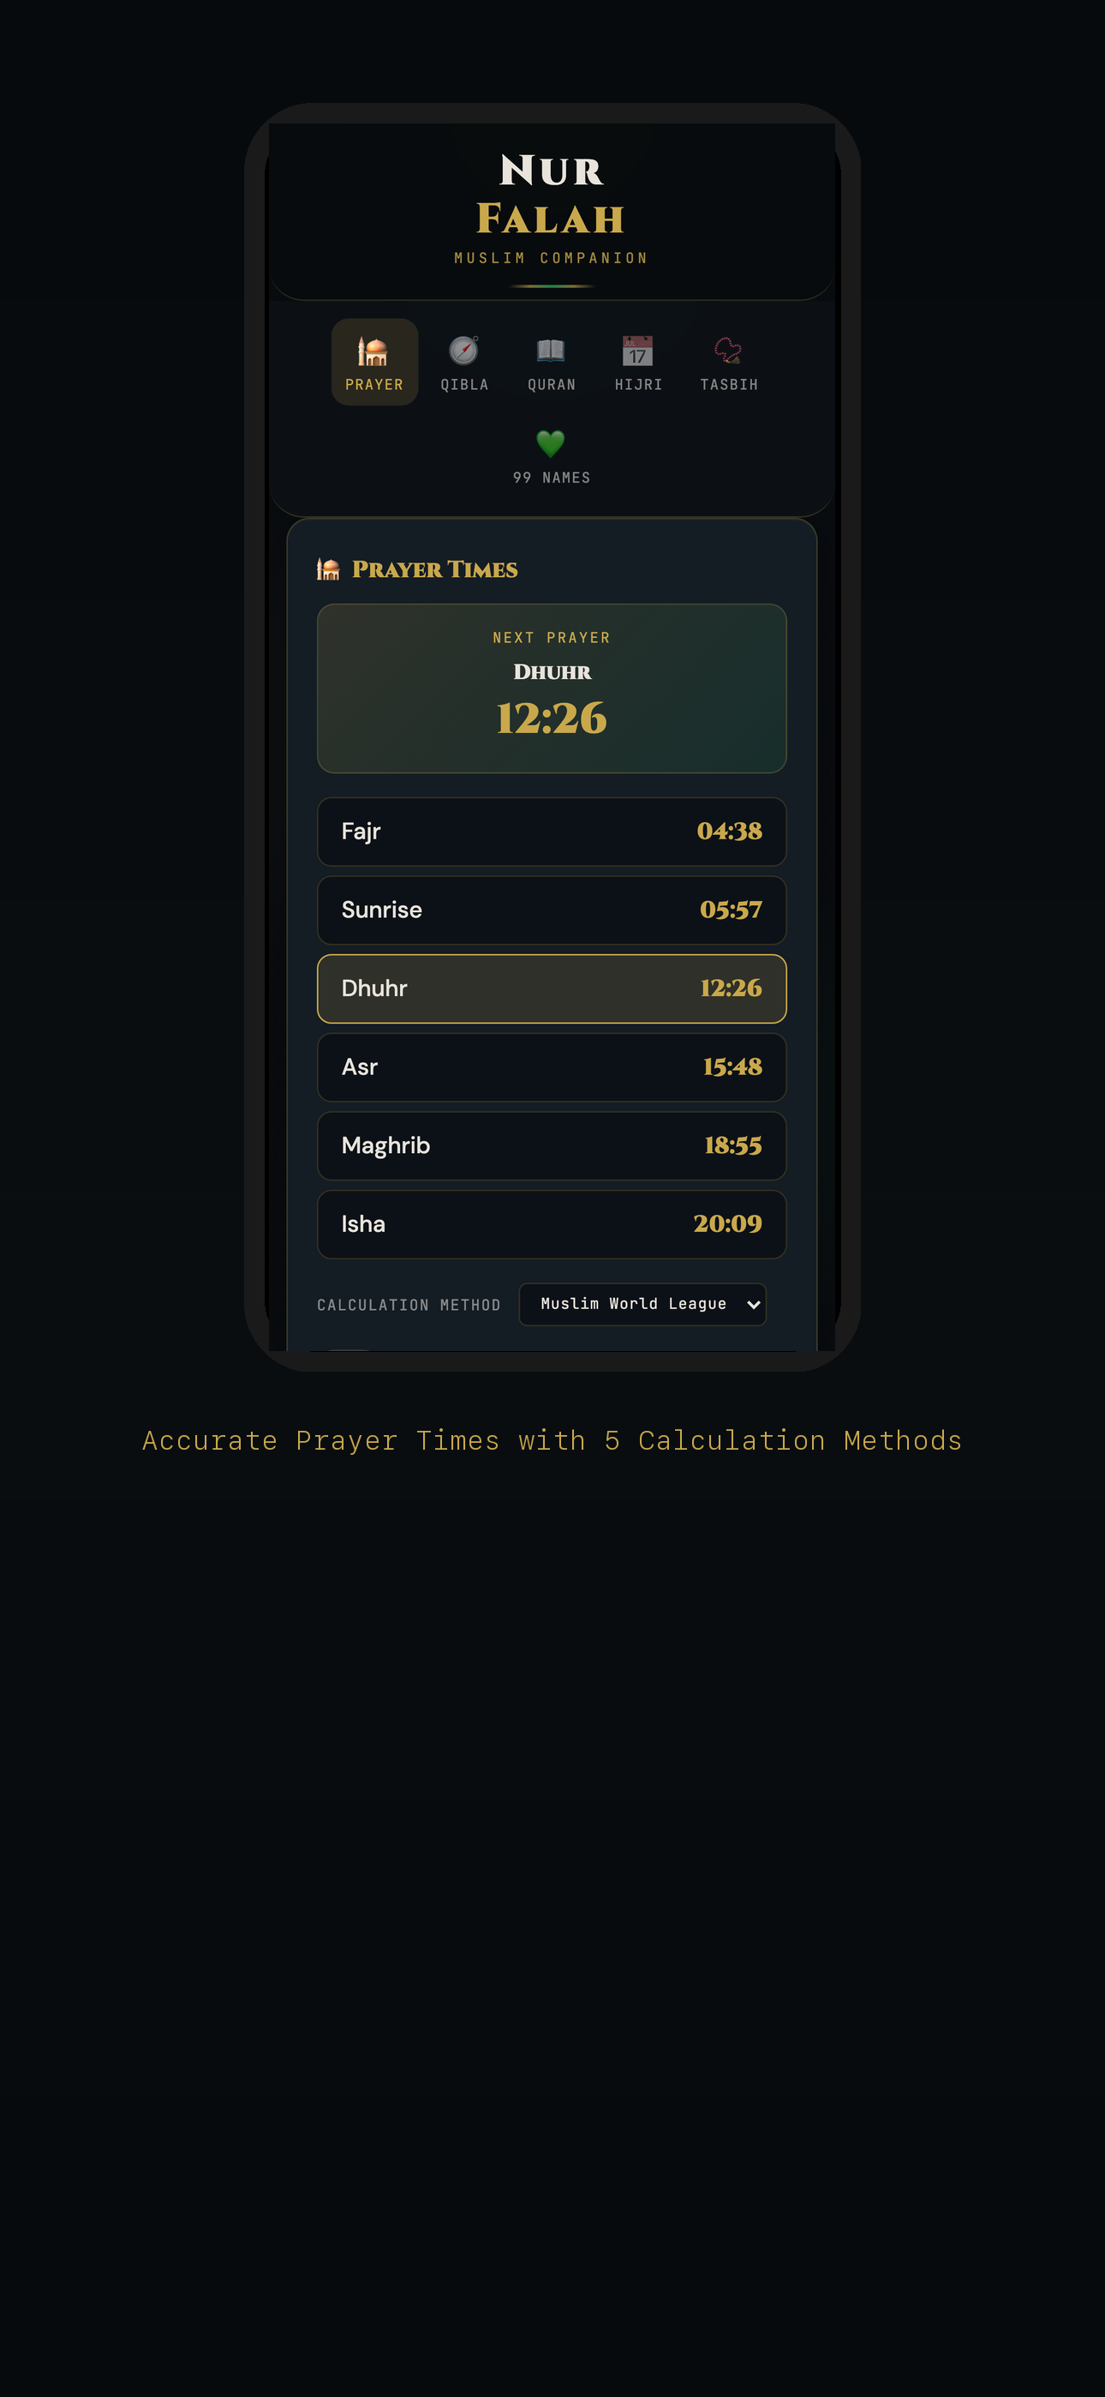

Screenshot 2: Qibla Finder — compass to Kaaba
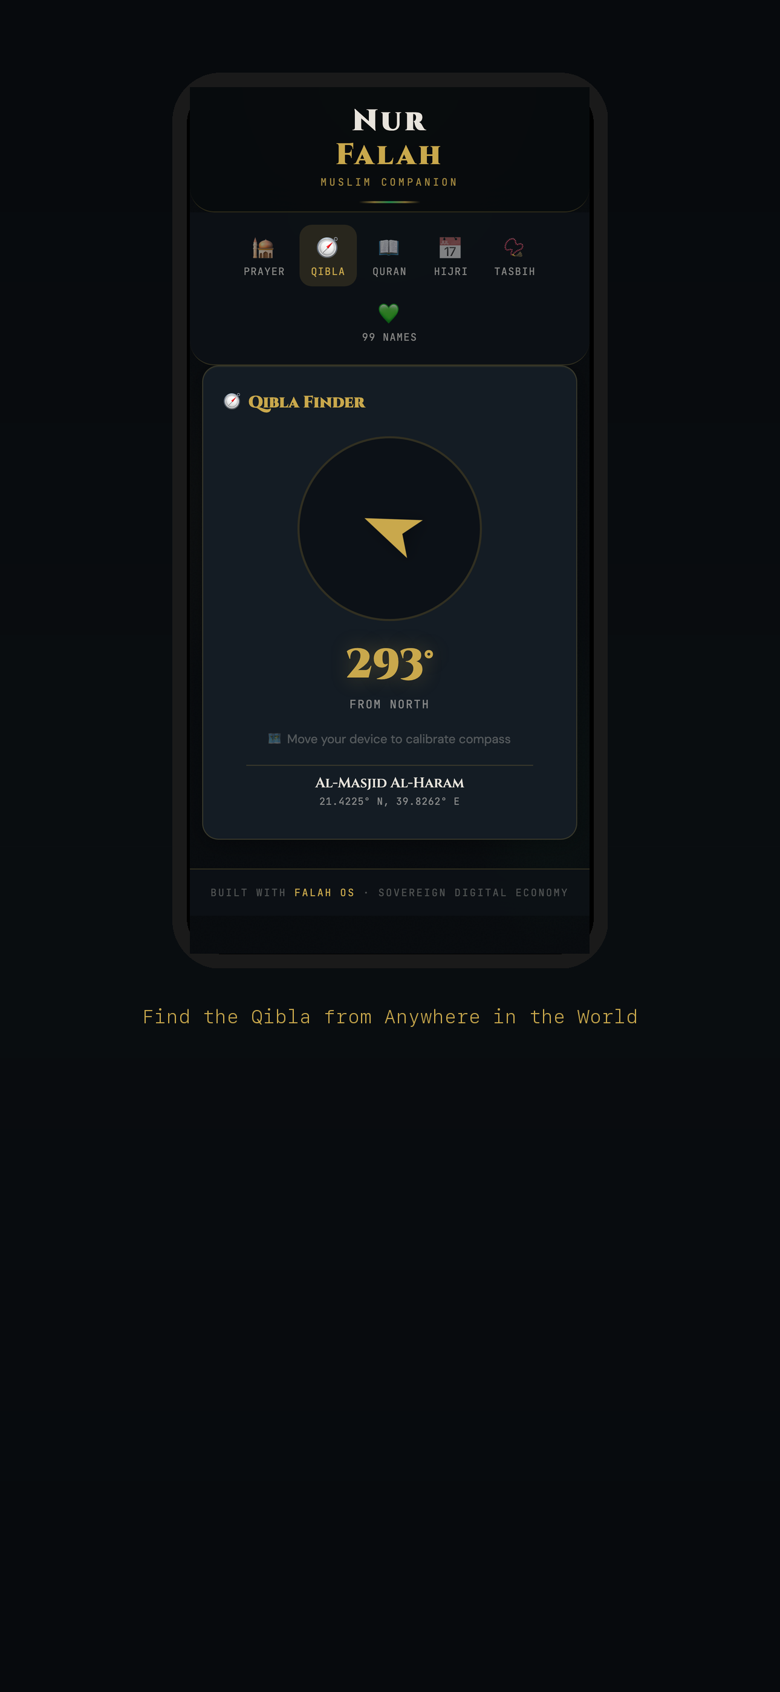

Screenshot 3: Holy Quran — all 114 surahs
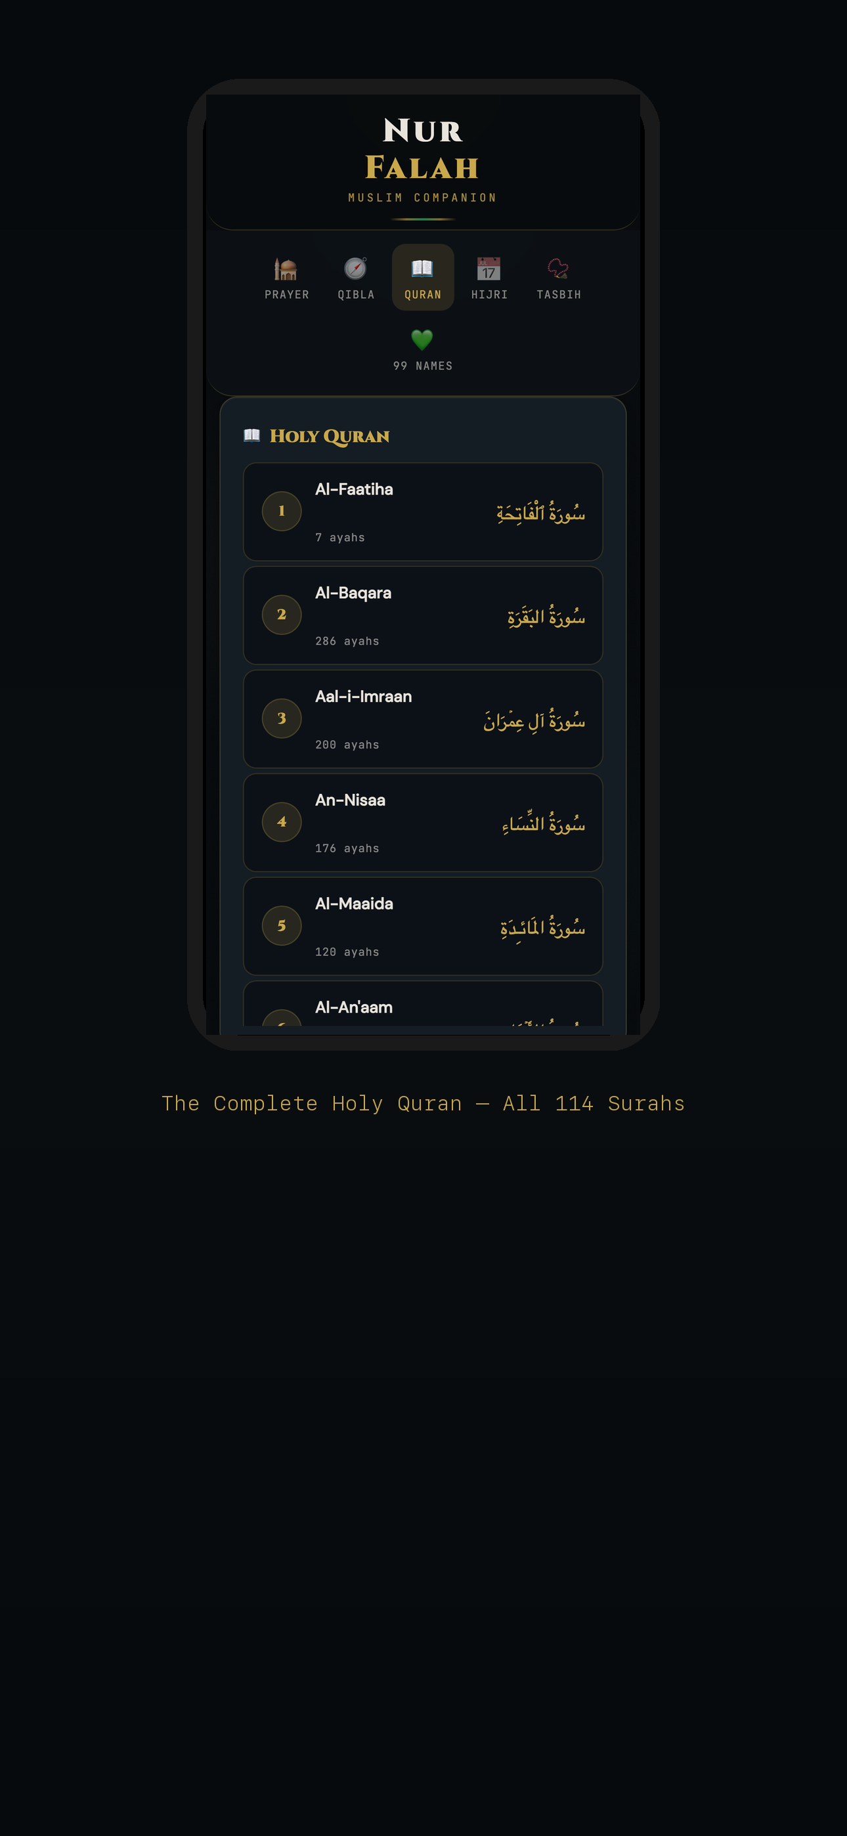

Screenshot 4: 99 Names of Allah — Asma-ul-Husna
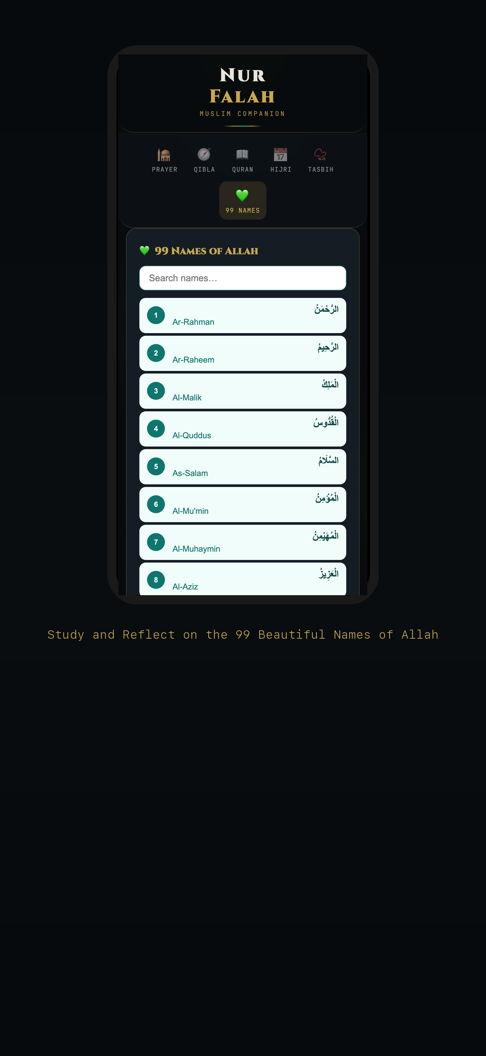

Screenshot 5: Tasbih Counter — digital dhikr
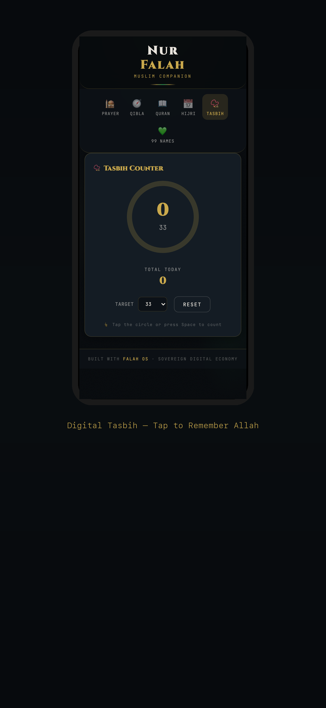

Screenshot 6: Hijri Calendar — Islamic date
